Date : 07-04-2024

**Auto Scaling Group**

"Realtime"

EC2 >> Install, configure and enable all the pre-req for your application, test the application, once everything is tested,

AMI out of it >>>

Launch Template

Go to EC2 Dashboard >>> Create launch template

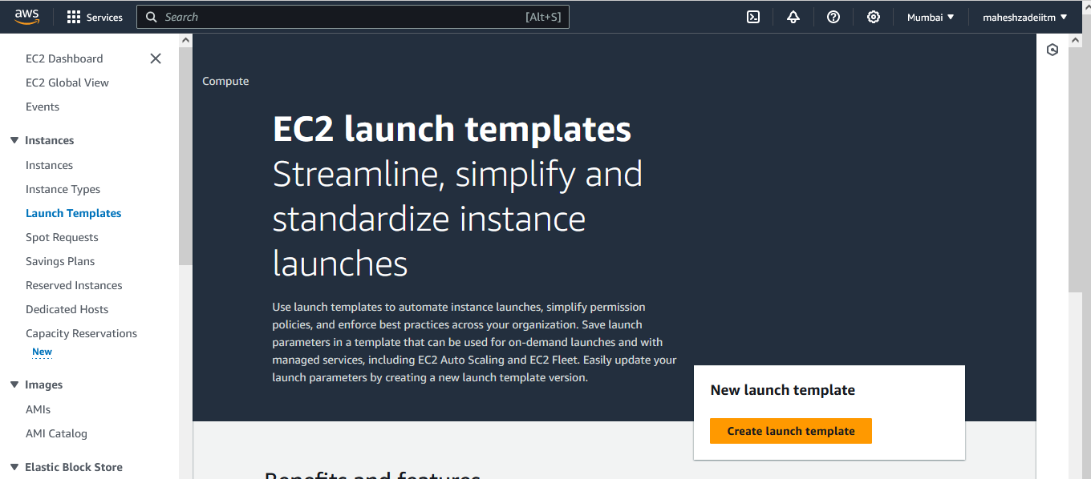

Launch template name - required >>> MaheshLTforASG

Version – Initial

Application and OS Images >>> Amazon Linux 2

AMI

Instance type >>> t2.micro

Key pair name>>> Dont include

Network settings

Subnet >>> public

Leave all other options and say - create Launch Template

Launch Template Created

Now > go to the Auto Scaling groups

Create Auto Scaling group

Name - MaheshASG

Launch template >>> Choose the Launch template which you have created above

Next

Network >>> Choose your VPC

Availability Zones and subnets >>> Choose min two AZ

Click on next

Load balancing >>> NO Load balancer

NO VPC Lattice

Leave all other options as it is and say >> Next

Review and create

Click on create auto scaling group

Now you can see new servers are creating automatically

Server is created

Watch out from Activity from ASG

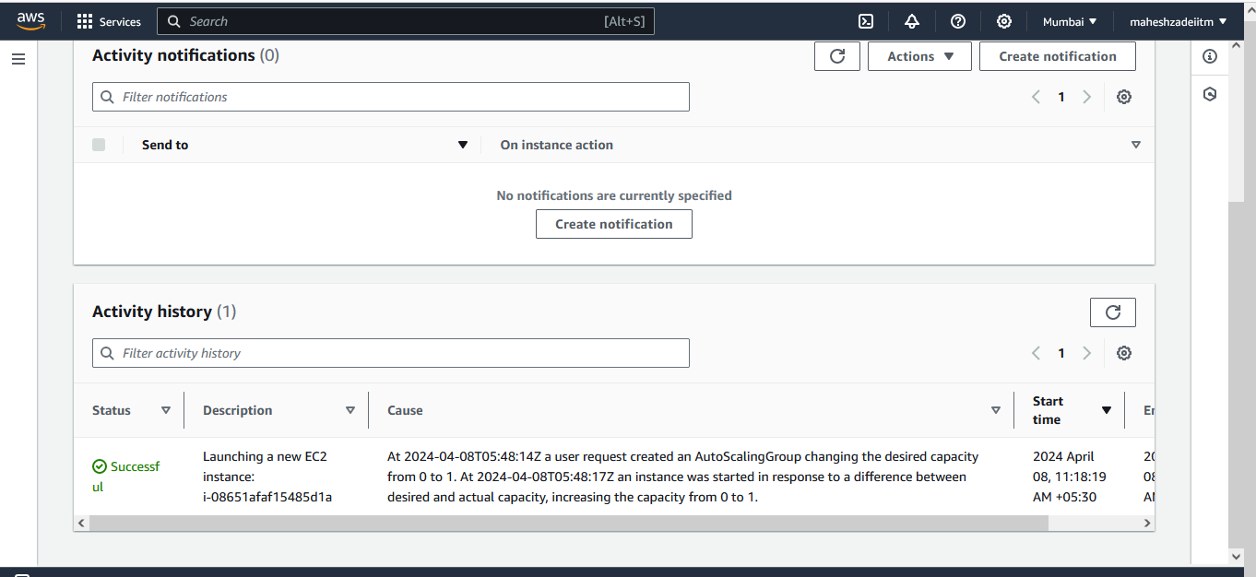

Edit

Change desired capacity and check in Instacnes

Play around with the Min, Desired and Max by changing the values

And activity

EC2 Instances increase to 3

And also terminate your servers and see if new are getting launched.

All 3 Instances Deleted .

Go to ASG and check the Activity

Again Check Activity in ASG

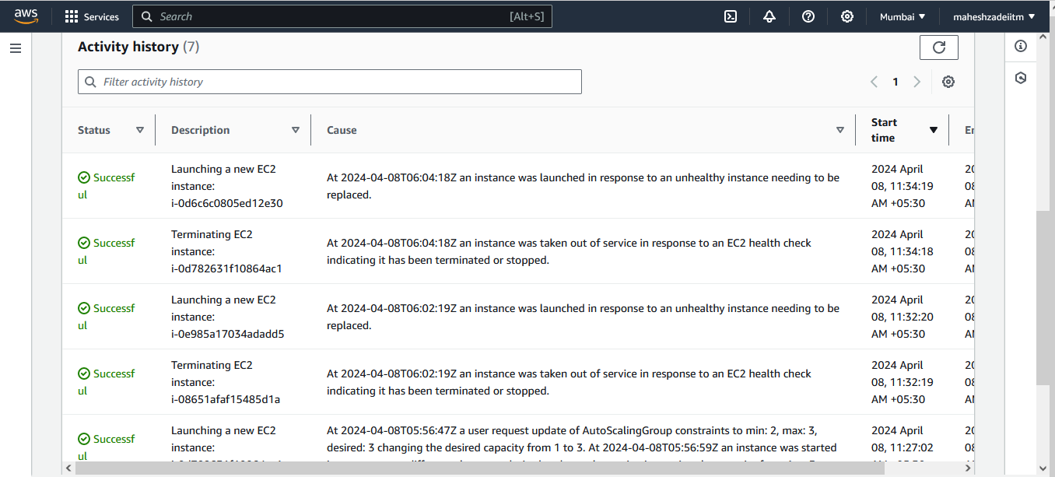

Now go to EC2 and check servers are again created again even after deletion 3 EC2 Instances .

Now Clean the LAB

EC2 Intances Terminate

Noe Delete the ASG

Thanks

Pls check and update